Order Details Page

Thursday, October 6, 2022  
Changes by Nicholas Holtman

Original layout:

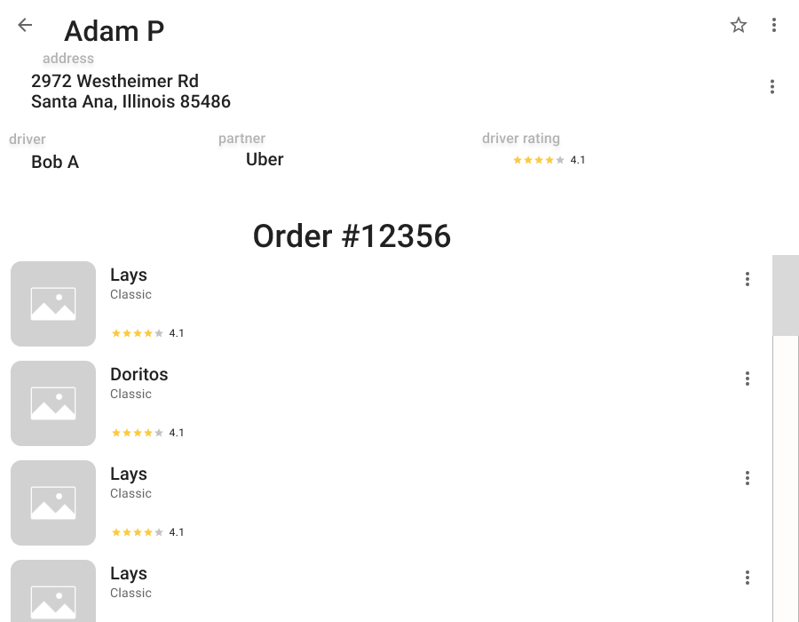

New layout:

